About Me

Tony Schuh

Table of Contents

# Who I am and where I came from

I grew up in a small town in northern Wisconsin. I have a bit of experience using Ubuntu Linux from when I was a teenager (~2010). My uncle gave me his old computer and I was allowed to keep it in my room. I mainly used the computer for pirating music and movies, and quickly found that Windows was not well suited to these enterprises. I eventually turned that computer into a media server which would allow me to remotely access my pirated material from other devices. Since I lost my appetite for these nefarious activities, I have not touched a linux machine.

I attended the University of Wisconsin: La crosse for my undergrad degree where I majored in Cell and Molecular Biology. During my undergrad I took an intro to computer science class where I learned the principals of coding and how to use Java. After I graduated, I moved to Egg Harbor Wi, where I spent a year working as a brewer at Shipwrecked Brewpub and figuring out what I wanted to do with my life. I eventually became tired of being perpetually broke and secured a job at Mayo Clinic in Rochester Mn, working in their Clinical Genomics Lab; first as a technologist, then as a lead technologist, and finally as a technical specialist. While there I learned a lot about lab work and NGS, and a bit about bioinformatics and IT.I also taught myself how to use VBA so I could create time saving excel macros in VBA for my lab work.

After 5 years at Mayo Clinic, I once again decided it was time for a career change and here I am now at CSU studying plant breeding and genetics.

1. Gardening
2. Reading
3. Hiking
4. Cross Country Skiing
5. Finding good restaurants
6. Snowboarding

Here is a picture of me making crosses last summer:

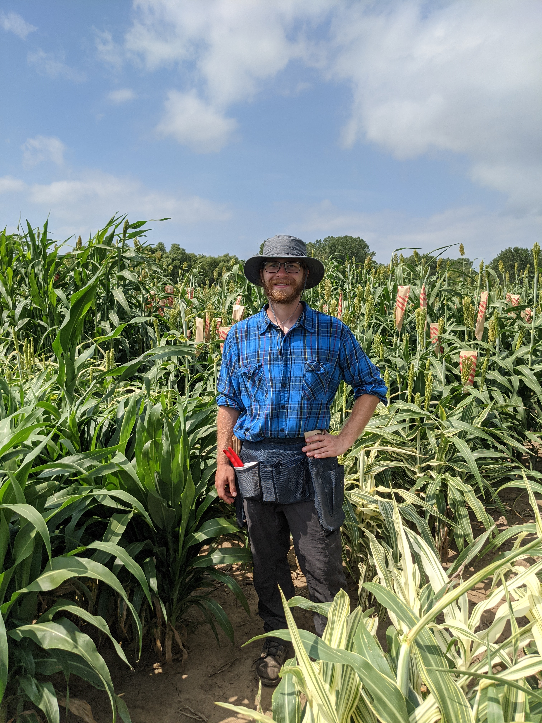

# Research Interests

I am interested in learning about and improving Global and U.S. food systems with an emphasis on food security and sustainability. My current research centers on clarifying the connections between genotype and phenotype for early season chilling tolerance in sorghum; an important trait with potential to contribute to drought avoidance in U.S. sorghum farming.

## Influential papers

I am pretty new to research. So far, there are two papers which are influential to what I am currently doing as my current research builds upon them. The first one Marla et al. (2019) is a mapping experiment of chilling tolerance QTL, and the second one, Marla et al. (2017) is a comparative lipidome-transcriptome experiment of chilling tolerant germplasm.

## The mathematics behind my research

This is the breeders equation. It describes the response in the next generation for a given level of heritability and selection

$$R=h_{2}S$$

These are the Hardy Weinberg equations

$$p^{2}+2pq+q^{2}=1\text{ and }p+q=1$$

## My computing experience

I learned Java during my undergrad in an introduction to computer science course. During my time at Mayo Clinic I also learned VBA to create time saving excel macros. I have learned R here at CSU to some degree.

Here is a the begining of my code which I use to create greenhouse experiment layout

#set working directory  
setwd("G:/.shortcut-targets-by-id/0B30URweoz3o4YTB4NlNKdlItNmc/Morris lab/Tony Lab Folder/Experiments/4_GCOptimization/Rep1/WD")  
Experiment_ID<- "GC_Optimization_4.1"  
#enter growth chamber IDs  
Growth_Chamber_ID <- c("GC1",  
 "GC2")  
#enter treatments (corresponding to growth chambers above)  
Treatment<- c("Optimal",   
 "Chilling")  
#Enter number of trays that will be used for each treatment  
TrayPerTreatment <- c("T1")  
#enter number of pots per row in a tray  
Tray_Width <- 3  
#enter number of pots per column in a tray  
Tray_height <- 10  
#enter genotypes being used per treatment per replicate (below)  
Genotype <- c("BTX623",  
 "HKZ",  
 "ADV_G2275")  
#enter how many times each genotype should be repeated per treatment   
GenotypeReplicates <- 10  
#Change seed for unique layout  
seed <- 10  
#calculate how many pots per tray based on user entry  
potPerTray<- Tray_Width*Tray_height  
  
  
#replicate each genotype per user entry   
#Genotype variable now contains the genotypes for an entire treatment  
Genotype <- rep(Genotype, each = GenotypeReplicates)  
#save the number of genotypes at this point as it represents the number of   
#genotypes per treatment  
numGenotypes <- length(Genotype)  
#initilize blank temporary vector for the loop below  
temp2 <- c()  
#find how many treatments were entered by the user  
numTreatment <- length(Treatment)  
#find the number of trays per treatment that were entered by the user  
numTray <- length(TrayPerTreatment)

I don’t have any examples of the code I wrote in VBA as it was not on my personal computer, but here is an example I copied from the internet that will highlight alternate excel rows.

Sub highlightAlternateRows()  
Dim rng As Range  
For Each rng In Selection.Rows  
If rng.Row Mod 2 = 1 Then  
rng.Style = "20% -Accent1"  
rng.Value = rng ^ (1 / 3)  
Else  
End If  
Next rng  
End Sub

## What I hope to get out of this class

* Learn to align genomes
* Get an introduction to the supercomputer
* Become better at using R

# Evaluating some R code

.

counts <- table(mtcars$gear)  
barplot(counts, main="Car Distribution",  
 xlab="Number of Gears")

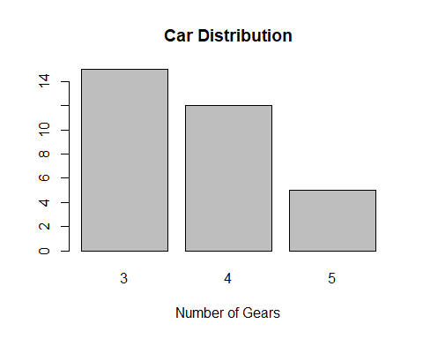

# Citations

Marla, Sandeep R, Gloria Burow, Ratan Chopra, Chad Hayes, Marcus O Olatoye, Terry Felderhoff, Zhenbin Hu, Rubi Raymundo, Ramasamy Perumal, and Geoffrey P Morris. 2019. “Genetic Architecture of Chilling Tolerance in Sorghum Dissected with a Nested Association Mapping Population.” *G3: Genes, Genomes, Genetics* 9 (12): 4045–57.

Marla, Sandeep R, Sunitha Shiva, Ruth Welti, Sanzhen Liu, John J Burke, and Geoffrey P Morris. 2017. “Comparative Transcriptome and Lipidome Analyses Reveal Molecular Chilling Responses in Chilling-Tolerant Sorghums.” *The Plant Genome* 10 (3): plantgenome2017–03.